Kingston on Soar Village Plan

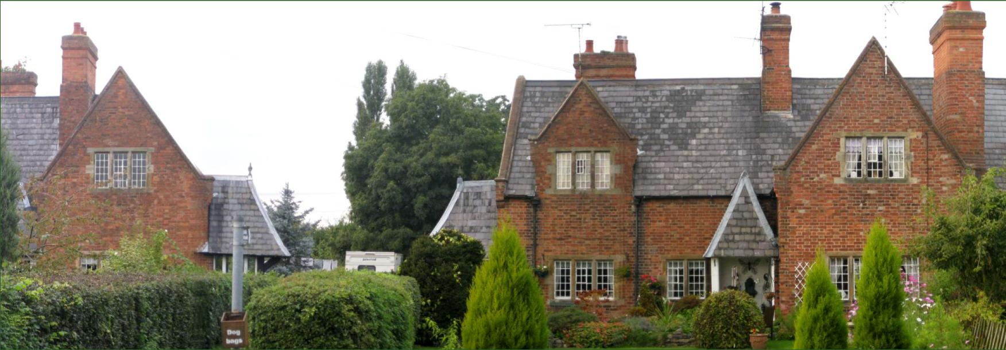
DRAFT July 2014
‘a plan for The village by The village’

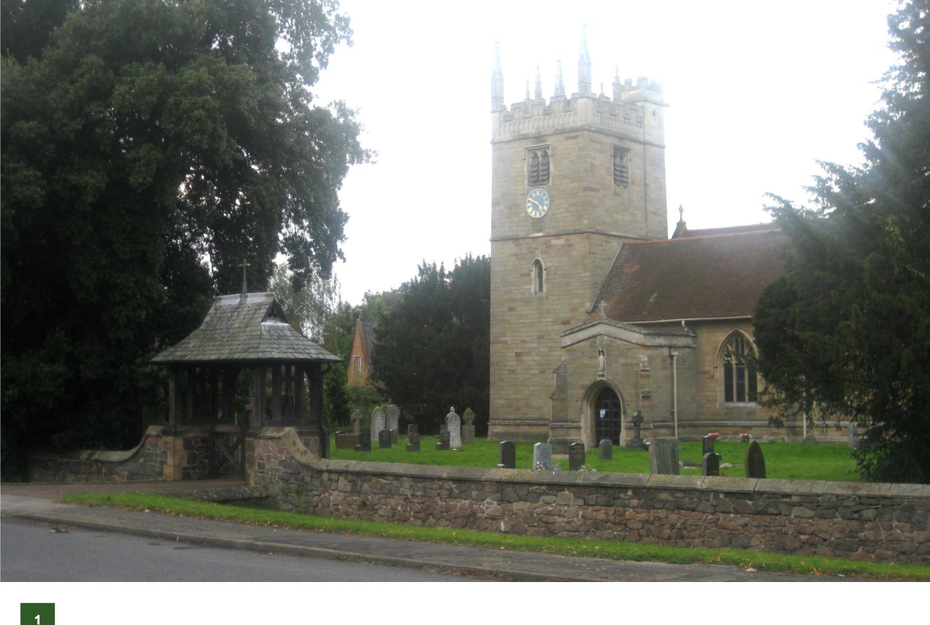

‘our village is special to us’  Why we have a Village Plan:  Our village is special to us and this plan will  - Identity the things we love and value about living here  - Represent a vision of how residents want their community to develop in the future  - Identify local challenges  - Involve the community as a whole to ensure that local concerns and needs are properly considered  - Provide a list of action points for the delivery of our plan | 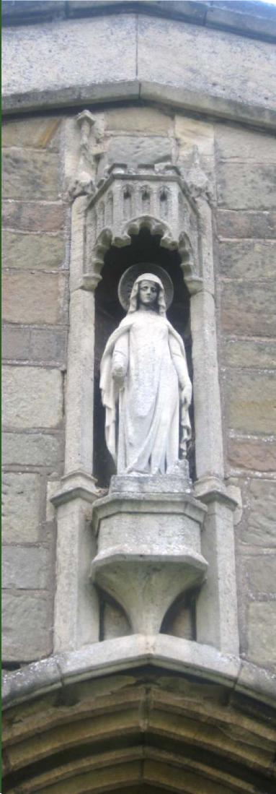

Why we have a Village Plan

2

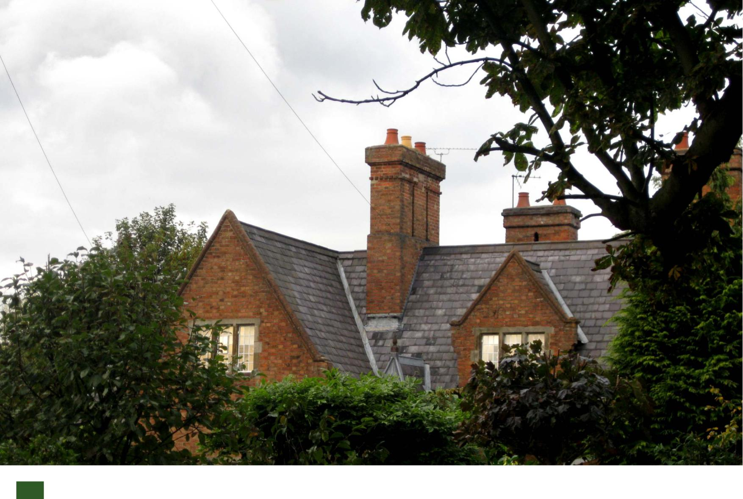
3

Kingston on Soar: Our Parish

Our parish consists of several settlements: Kingston on Soar, New Kingston, Kingston Hall and Kingston Court, with other areas of housing near the Station crossroads, and canal side properties on Kingston Lane.

The adult population of the village is 225 living in 111 households (based on the 2014 Electoral Register).

 |  | ‘what we value about our neighbourhood' |  | 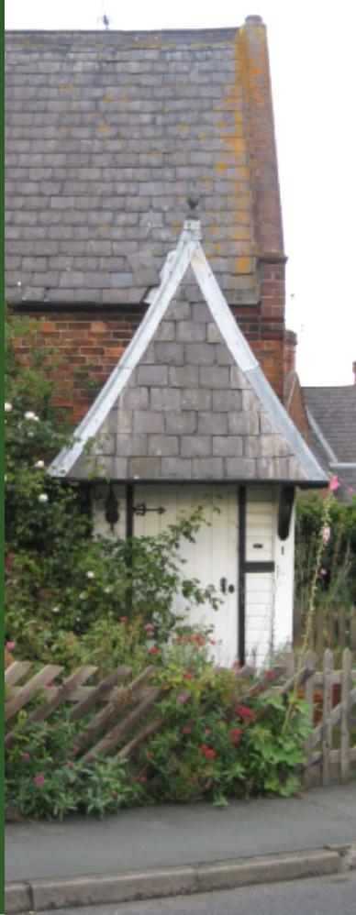
The residents of the neighbourhood of Kingston on Soar value our physical location and environment.

We love the combination of peace & quiet and the close proximity to good transport systems and towns.

Features that shape the character of our neighbourhood are the church, the green (including the trees and pump), the listed houses in the village centre, the village hall and the surrounding countryside including Kingston Brook. We like the buildings that mark our village as special, including Kingston Court, Kingston Hall, Church Farm and the Schoolhouse.

The open spaces and landscape surrounding the village are very important to us. These include The Green, Kingston Hall Park and farmland, other farms in the neighbourhood and the fields surrounding the village. We also treasure the West Leake Hills and woods. We enjoy using the local network of footpaths.

We want to conserve these things.

A vision for our Village

‘we don’t want to stand still but we must respect the past’
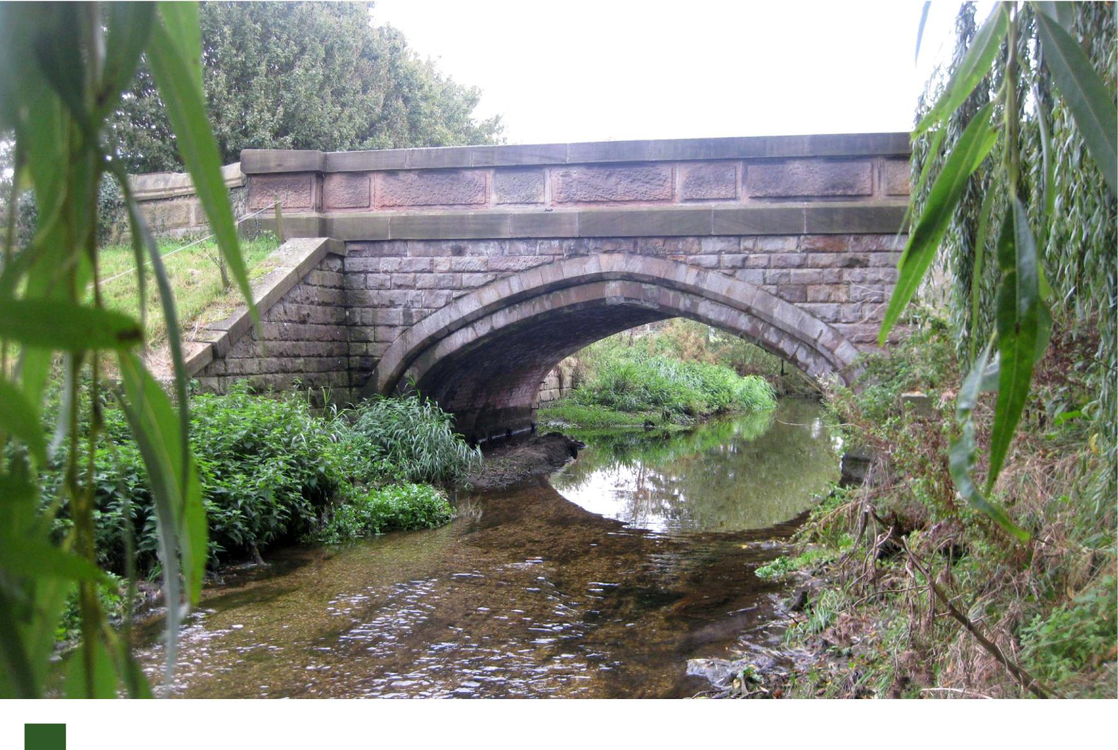
5

‘our vision for the future: conservation and limited development’  We  We want to conserve the features that we value and that make this a special neighbourhood in which to live.  Residents like the size of our village. We would support limited development of the village but not beyond 10% of its current size. We prefer conversion of existing buildings and the construction of a few single dwellings in controlled locations.  We strongly support the values that underpin conservation areas: namely that any development in the area should enhance and preserve its existing character, that the special architectural and historical appearance of the village should be preserved and also that any planning applications should protect and enhance the character of the village. | 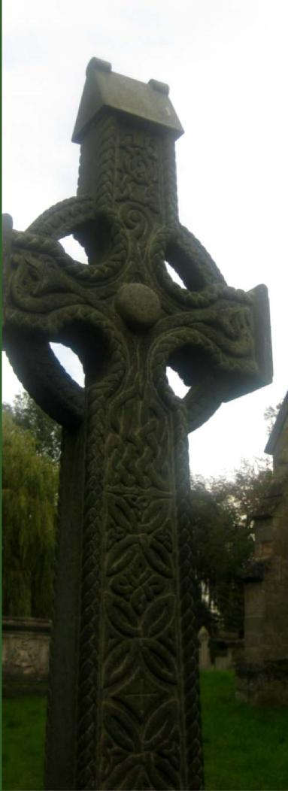
 |  | 6

‘We love our homes’

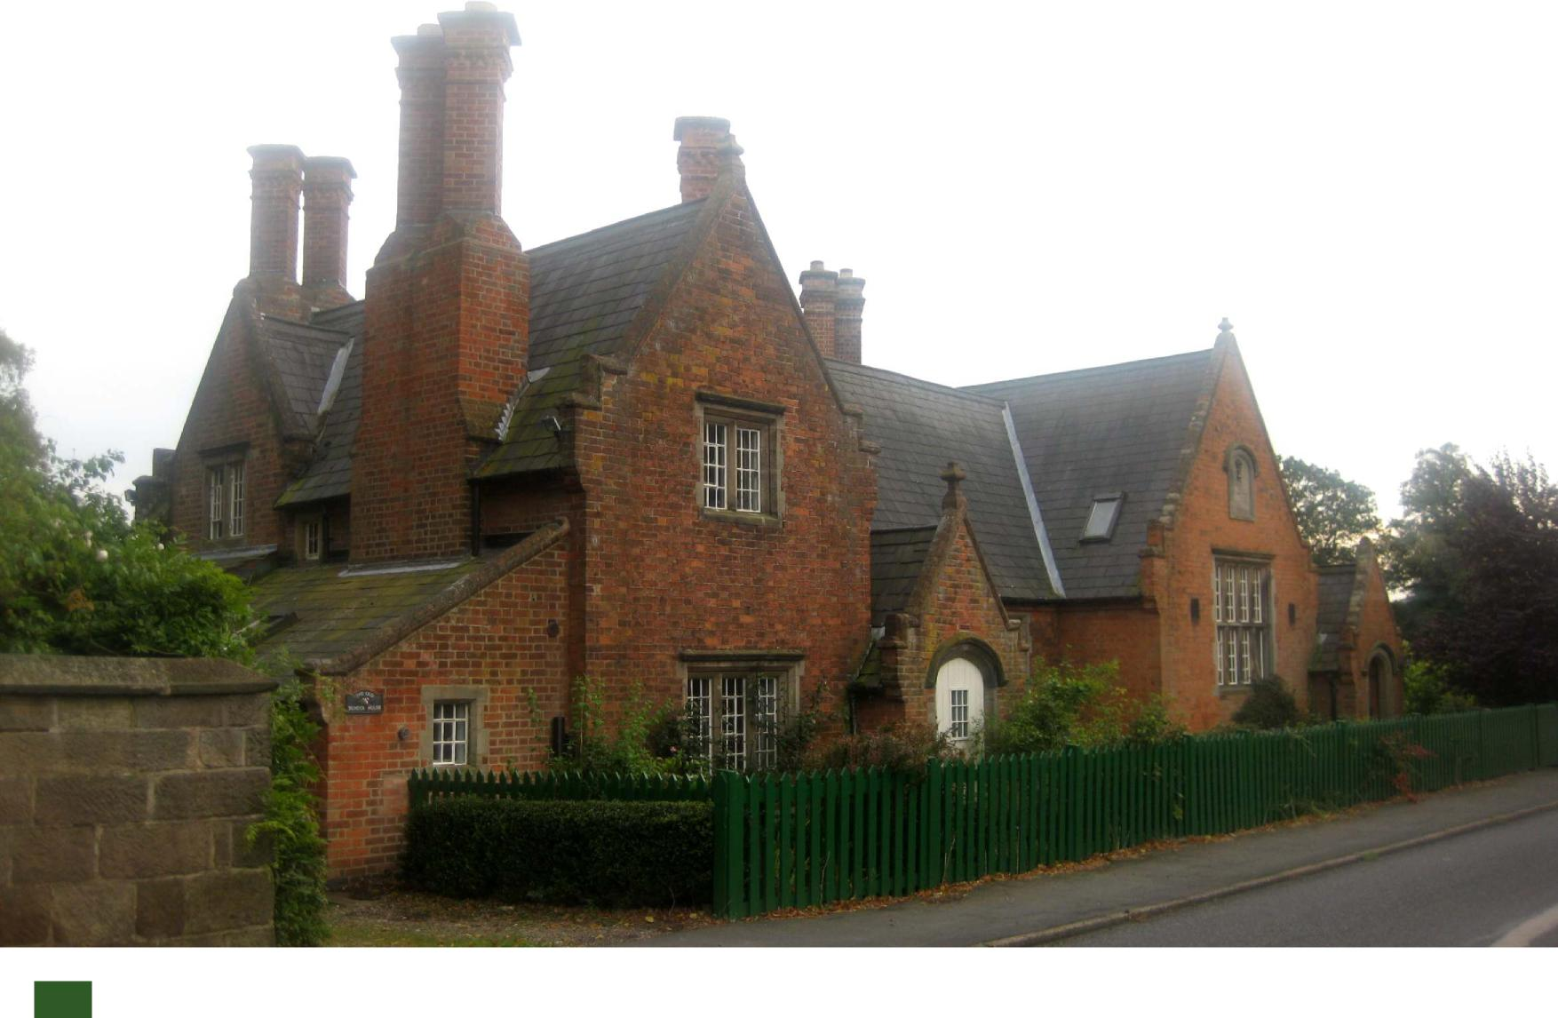
7

‘local challenges’ | 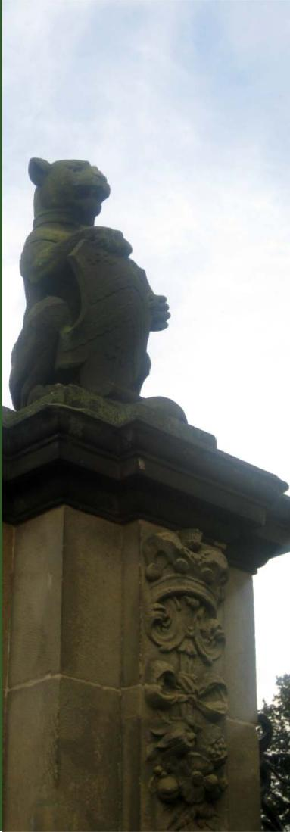
Our biggest local challenge involves traffic and we major challenges involving volume, speed, irresponsible driving and the nature of our traffic. The village experiences a large volume of fast moving traffic, especially during rush hours. This includes bicycles, cars, lorries and farm traffic, especially contract agricultural vehicles during harvest. This is a dangerous combination. We have a number of danger spots: West Leake Lane, Dark Lane, Station Road and the New Kingston crossroad.

Challenges
8

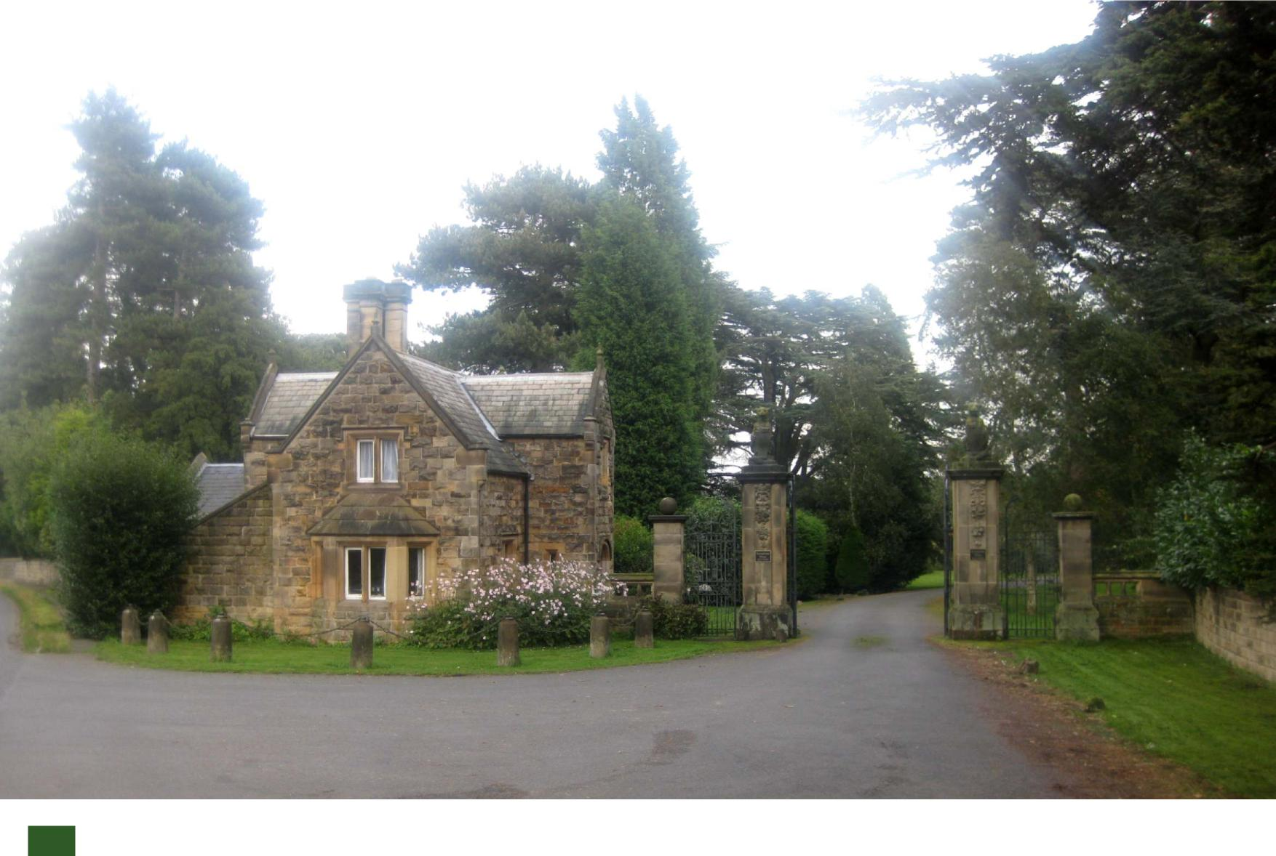
9

Our Community  We would like to expand our community activities, establishing new groups:  Parent and toddler group  Youth club  Community Composting Group  Good neighbour schemes  We value our village hall and the activities organised in it. We’d like more dances, films, theatre and exercise or yoga classes. | 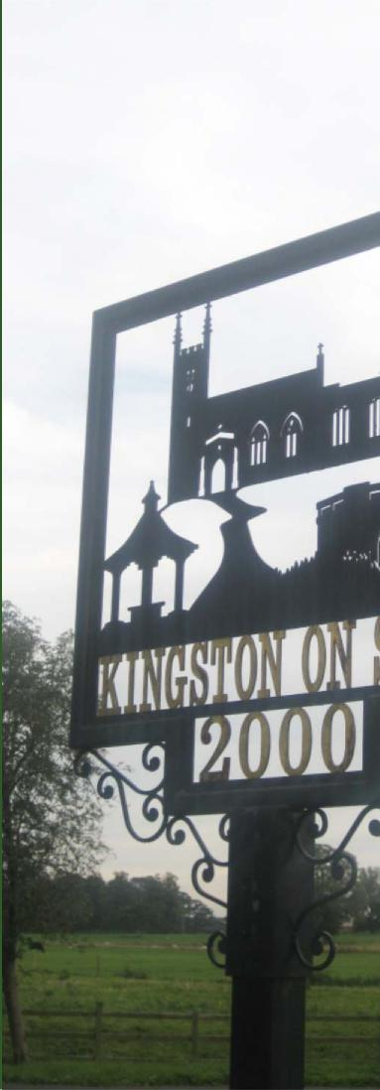

Community Development 10

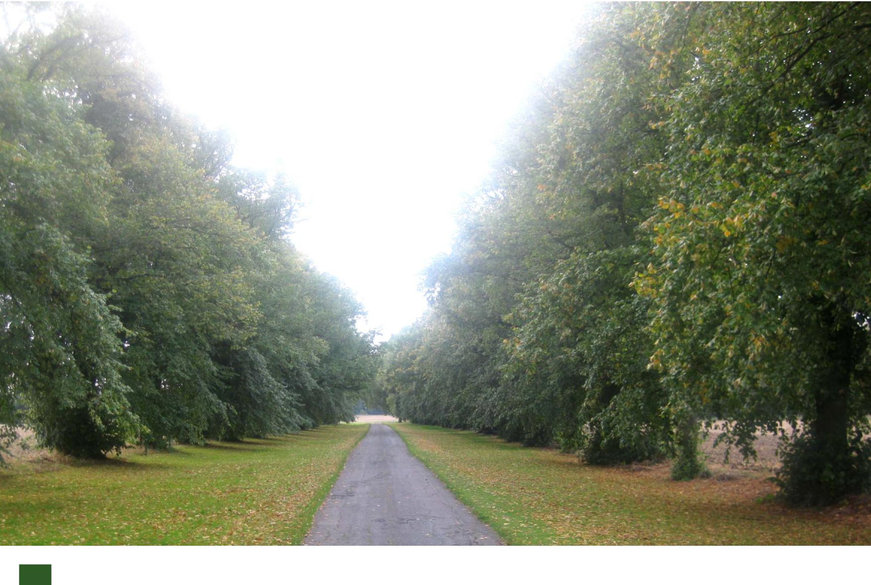
11

What change don’t we want 12
We reject any changes that would interfere with the character of our neighbourhood. We seek to protect and conserve the architectural features and buildings in the village and also the hills, woods, trees, river and landscape features.

‘the Village is shaped by its landscape setting’
A summary of what people don’t want for the village and how we can avoid inappropriate change
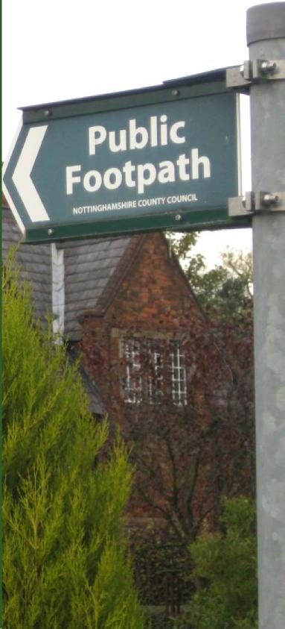

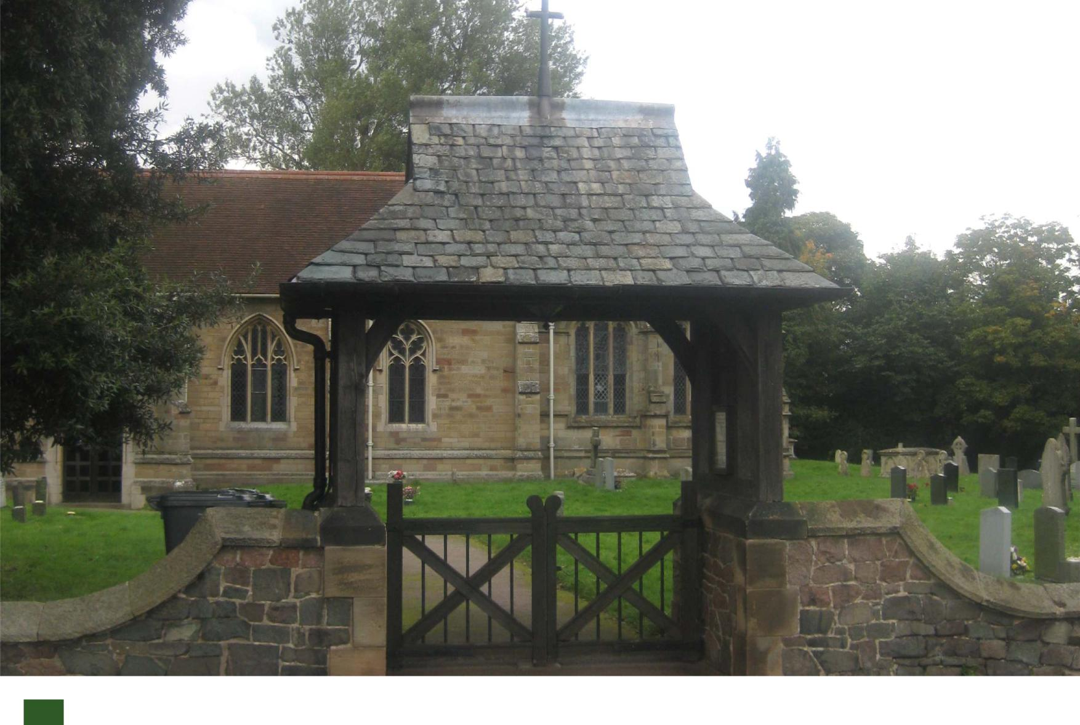
13

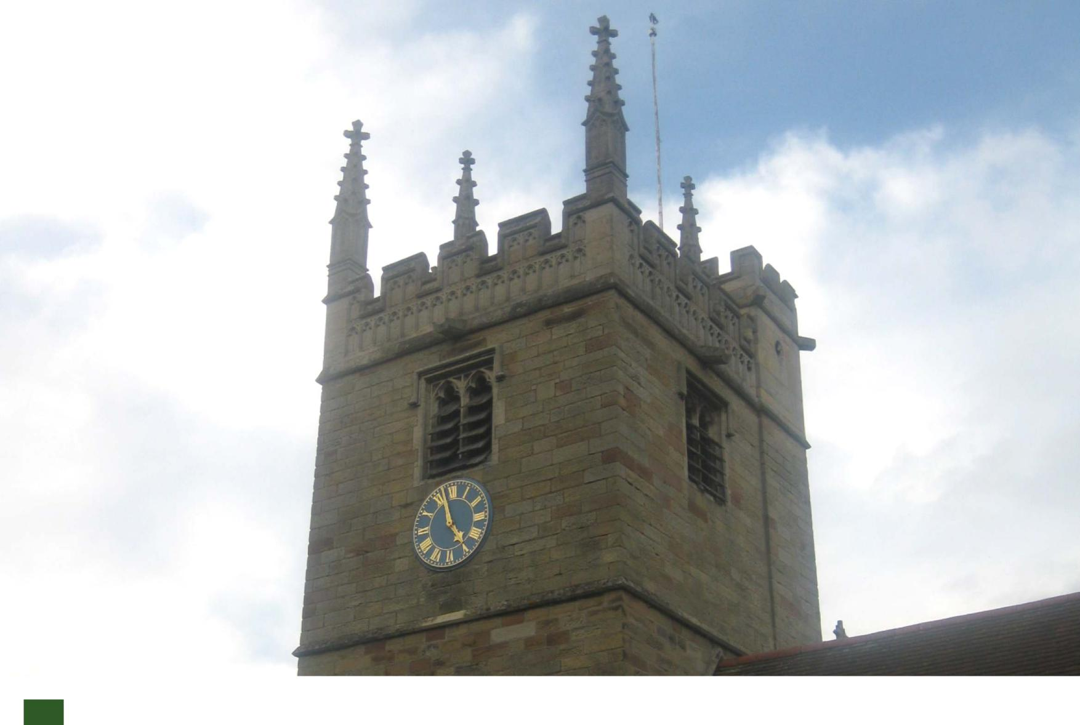
15

‘action points to deliver our plan’  For the Parish Council:  We support the introduction of traffic lights at the New Kingston traffic lights  We support the extension of the 30 mile an hour zone  We support the values of conservation areas  For the Hall Committee:  We support the introduction of more films, theatre, dance, yoga and exercise clubs.  For Residents:  The Steering Committee has contact details for people who expressed an interest in parent and toddler group, youth club, community composting group and good neighbour schemes. We will gladly put you in touch with each other. | 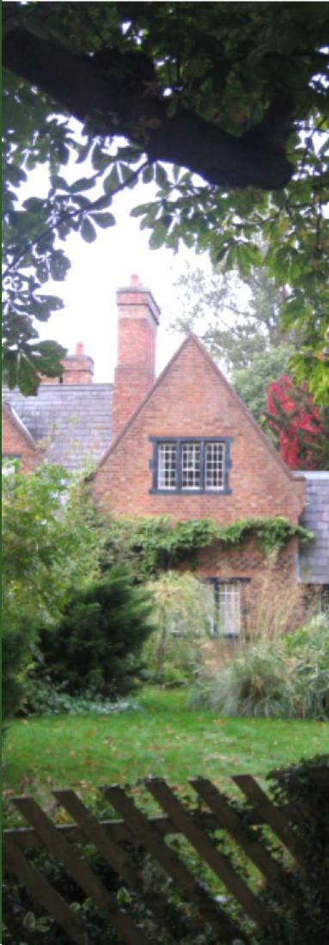

These our action points

16

Prepared by Kingston on Soar for Kingston on Soar

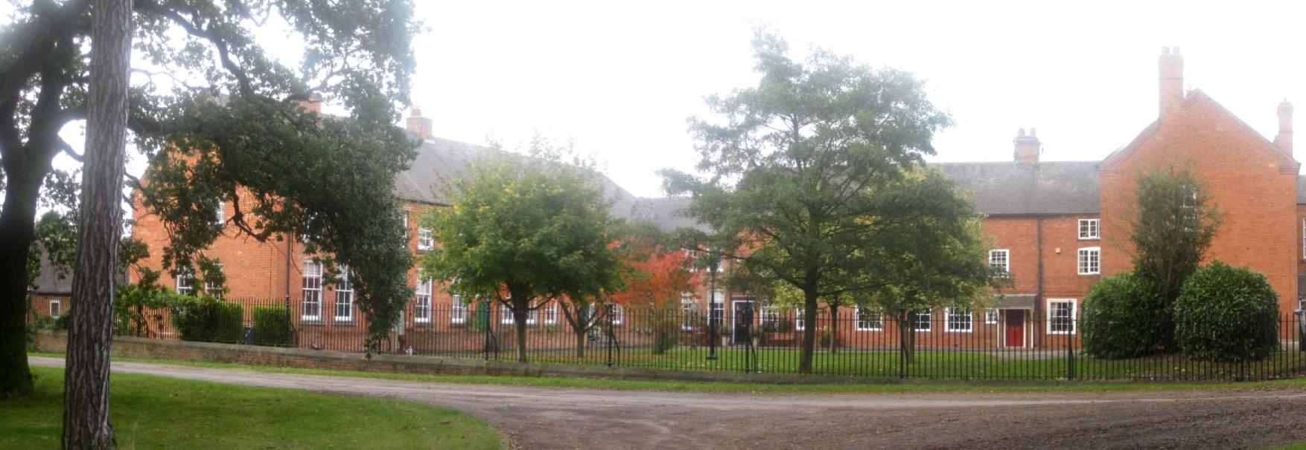
For further information please go to www.kingstononsoarvillageplan.org
At this website you will find further details about the Village and the steering group leading the development of the plan.
Kingston on Soar Village Plan

